|  |  |
| --- | --- |
| **Reg. #** |  |
| **Marks** |  |

**EXPERIMENT # 4**

**Design and simulation of Three Phase Controlled Rectifier**

**Controlled rectifiers**

Controlled rectifiers are line commutated ac to dc power converters which are used to convert fixed voltage, fixed frequency ac power supply into variable dc output voltage.

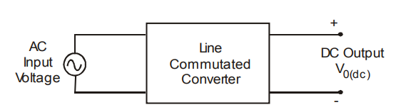

Type of input: Fixed voltage, fixed frequency ac power supply.

Type of output: Variable dc output voltage

The input supply fed to a controlled rectifier is ac supply at a fixed rms voltage and at a fixed frequency. We can obtain variable dc output voltage by using controlled rectifiers. By employing phase controlled thyristors in the controlled rectifier circuits we can obtain variable dc output voltage and variable dc (average) output current by varying the trigger angle (phase angle) at which the thyristors are triggered.

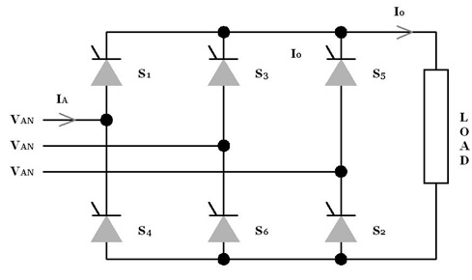

Figure 1: Three Phase Full Wave Rectifier

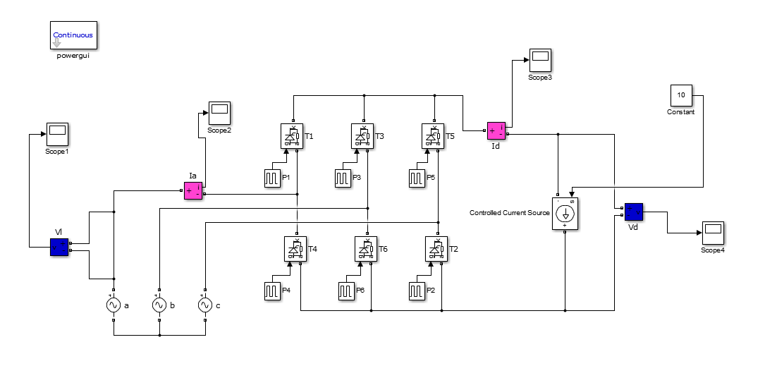

Figure 2: Three Phase Controlled Converter in Simulink

**Effect of Line Inductance in Controlled Converters:**

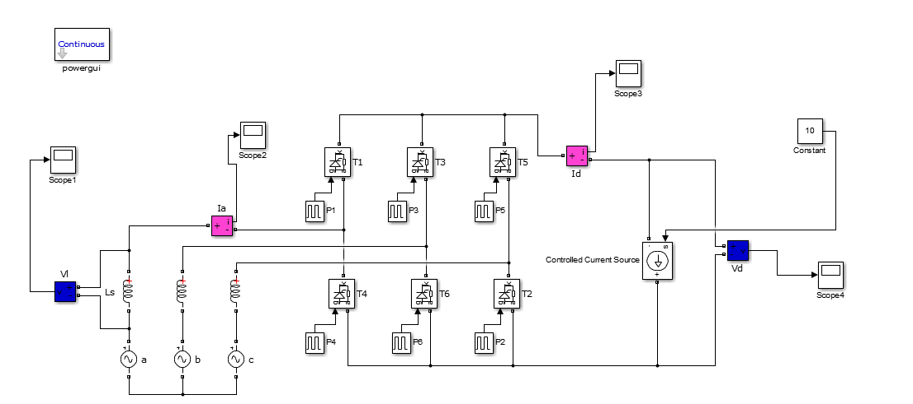

Figure 3: Three phase Controlled Converter using PWM generator with Line Inductance

**Tasks:**

* Design the AC/DC converter in Matlab/Simulink.
* Observe the output voltage waveform at 0, 30, 60, 90, 120 degree with resistive load.
* Observe the output voltage waveform after including Line Inductance at 0, 30, 60, 90, 120 degree with current source.

Design the converter and simulate in MATLAB. Put a snapshot of your Simulink file result below.

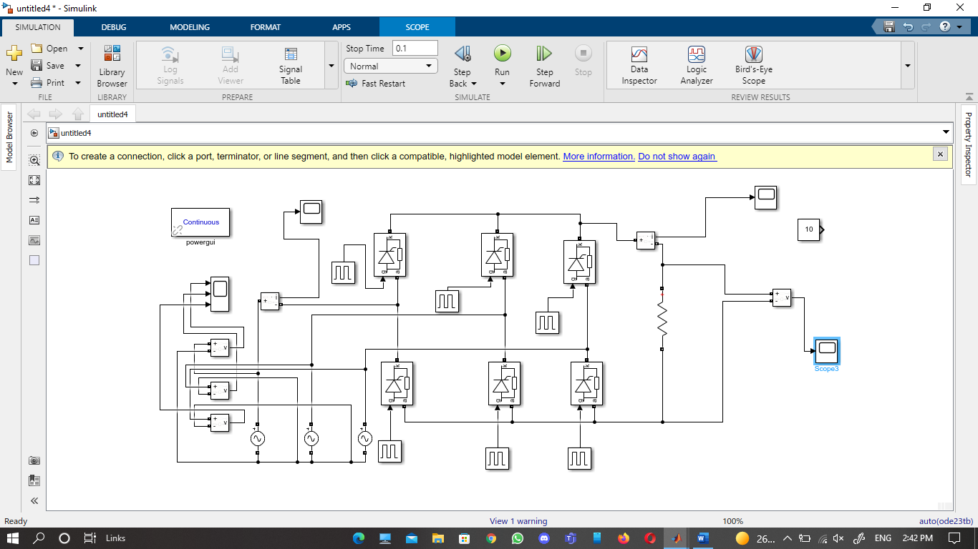

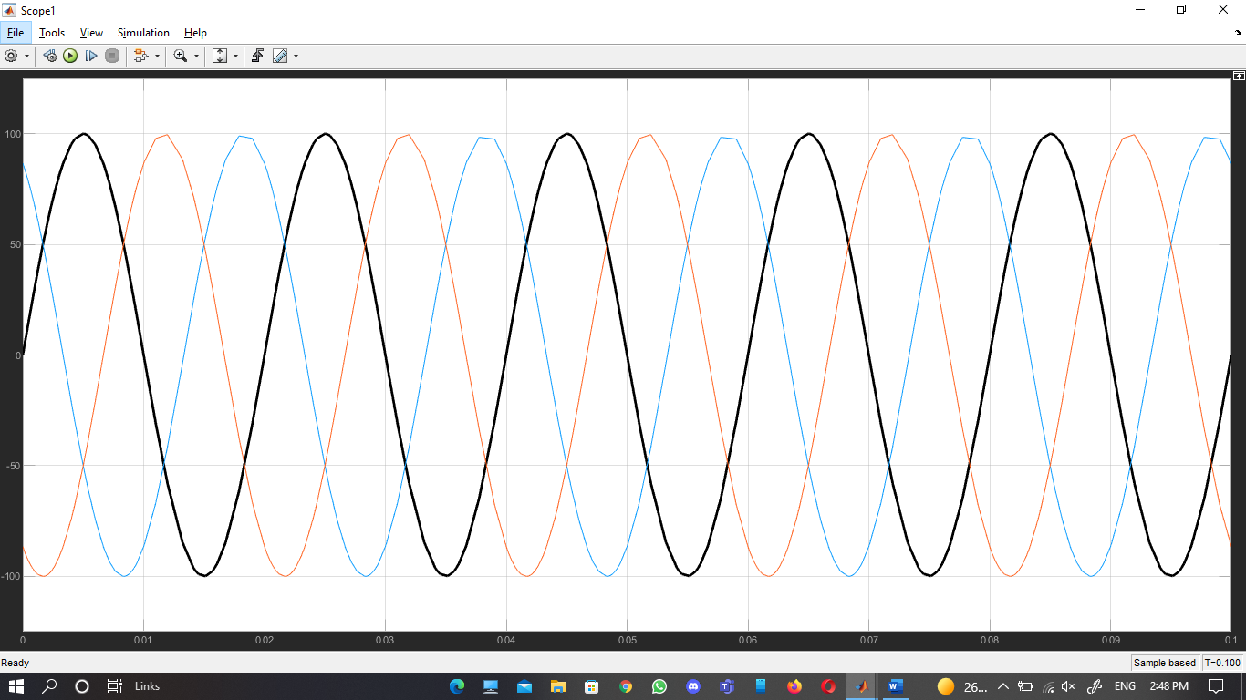

**Fire angle 0**

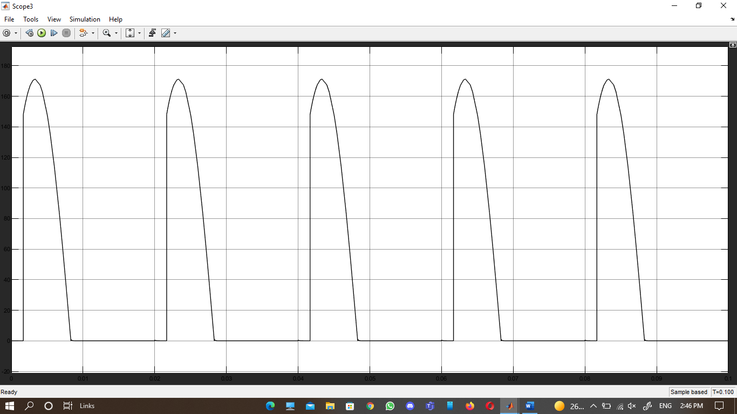

Fire angle 30

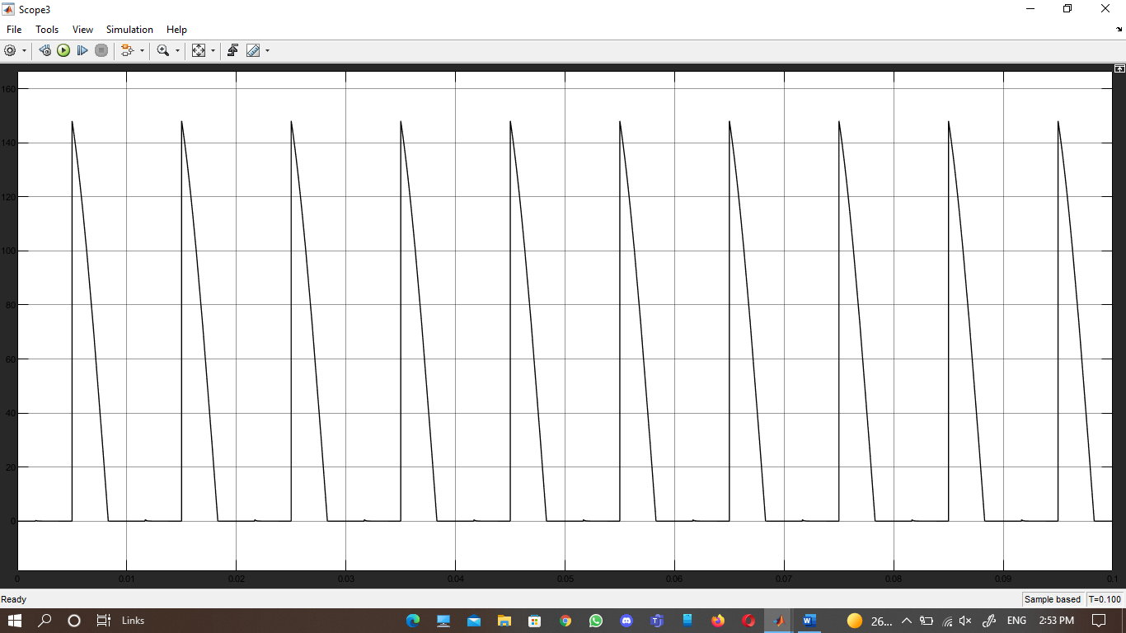

Fire angle 60

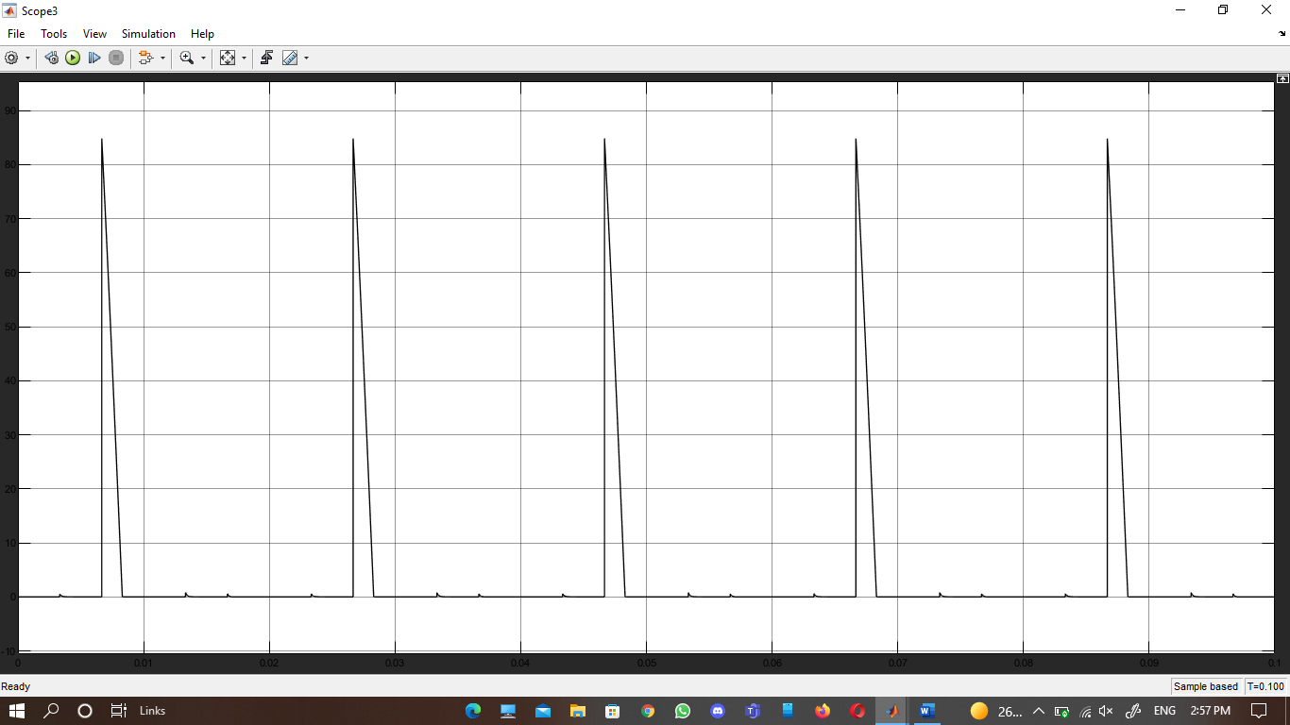

Fire angle 90

